UNIT 4

Q1) **Cloud Security Threats**.   
**1. Traffic Eavesdropping:** 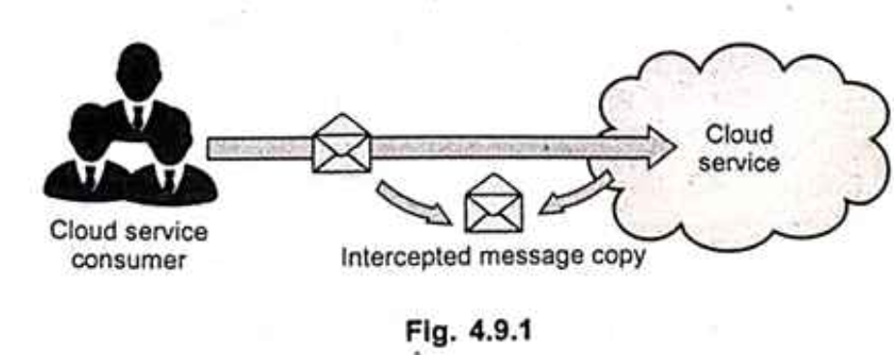  
This involves a malicious service agent **passively intercepting data** being transferred to or within the cloud.  
The goal is **illegitimate information gathering**.  
It aims to **discredit the confidentiality** of data and the relationship between the cloud consumer and provider.  
It can be **hard to detect** for a long time due to its passive nature.

**  
In this threat, messages are **intercepted and altered** by a malicious service agent.  
This aims to **discredit the message's confidentiality and/or integrity**.  
There's a possibility of **malicious content being inserted** before the message is forwarded to its intended destination.

**3. Denial of Service (DoS):**  
This involves **intentional sabotage** of a shared physical IT resource.  
The attacker overloads the resource, making it so the IT resource can **hardly be allocated to other consumers** sharing the same resource.  
Typically achieved by **generating excessive messages, consuming full network bandwidth, or sending multiple requests** that consume excessive CPU time and memory.

**4. Insufficient Authorization:**     
This occurs when an attacker is **erroneously or too broadly granted access** to IT resources that are normally protected.  
Another case (Weak Authentication) involves the use of **weak passwords or shared accounts** to protect IT resources.

**5. Virtualization Attack (Overlapping Trust Boundaries):**  
This is inherent in the nature of resource virtualization, where **physical resources are shared by multiple virtual users** in a virtualized environment.  
There is a **possible inherent risk that some cloud consumers could abuse their access right to attack the underlying physical IT resources**.   
-------------------------------------------------------------------------------------------------------------------------------------------------------------------------------  
Q2) **Hadoop Distributed File System (HDFS)**Hadoop Distributed File System (HDFS) is a distributed file system inspired by GFS that organizes files and stores their data on a distributed computing system.   
The Hadoop core is divided into two fundamental layers: the MapReduce engine and HDFS.   
The MapReduce engine is the computation engine running on top of HDFS as its data storage manager   
Hadoop is an open-source software framework that supports data-intensive distributed applications, licensed under the Apache v2 license. It provide software framework for distributed processing of large datasets in real-time applications.   
Hadoop provides the basic platform for big data processing. The hadoop architecture have mainly two parts: Hadoop distributed File System (HDFS) and the MapReduce engine.   
HDFS is Distributed Files system designed to run on commodity hardware, which is highly fault- tolerant and scalable. 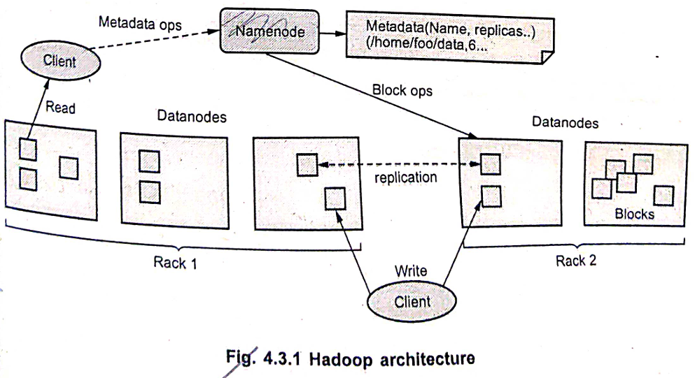  
• Block-Structured File System: HDFS is a block-structured file system where each file is divided into blocks of a pre-determined size. These blocks are stored across a cluster of one or several machines.     
Master/Slave Architecture: Apache Hadoop HDFS Architecture follows a Master/Slave architecture, where a cluster comprises a single NameNode (Master node) and all the other nodes are DataNodes (Slave nodes).     
File Storage: To store a file in this architecture, HDFS splits the file into fixed-size blocks (e.g., 64 MB) and stores them on workers (DataNodes).     
Deployment: HDFS can be deployed on a broad spectrum of machines that support Java. Though one can run several DataNodes on a single machine, in the practical world, these DataNodes are spread across various machines.     
NameNode Role: The NameNode is the master node in the Hadoop HDFS Architecture. It maintains and manages the blocks present on the DataNodes (slave nodes).  
NameNode Characteristics: The NameNode is a very highly available server that manages the File System Namespace and controls access to files by clients.     
DataNode Role: The DataNodes are the slave nodes in HDFS. Unlike the NameNode, a DataNode is a commodity hardware, meaning it's a non-expensive system which is not of high quality or high-availability. The DataNode is a block server that stores the data in the local file system (ext3 or ext4).     
Journal: The Journal is the modification log of the image, which is available in the local host's native file system. The Journal is updated for every client transaction.  
Checkpoint: The Checkpoint is a persistent record of the image, which is also stored on the local host's native file system to enable recovery. The NameNode is not allowed to update or modify the Checkpoint file.  
Administrator/Checkpoint: An Administrator or Checkpoint Node can demand to create a new checkpoint file on startup or restart.  
----------------------------------------------------------------------------------------------------**---------------------------------------------------------------------------  
Q3) What is meant by Disaster Recovery? Discuss Threats in Disaster Recovery.  
Disaster Recovery (DR)** is a strategic approach that involves a set of policies, tools, and procedures designed to recover and protect IT infrastructure, data, and systems in the event of a disaster—whether natural, technical, or human-induced. The goal is to restore normal business operations quickly and minimize data loss, downtime, and financial impact.

Disaster Recovery is a **key component of Business Continuity Planning (BCP)** and often includes:

* Regular data backups (on-premise or cloud)
* Recovery Point Objective (RPO)
* Recovery Time Objective (RTO)
* Replication and failover systems

**Threats in Disaster Recovery:  
1. Natural Disasters:**Earthquakes, floods, hurricanes, fires, and storms can physically damage data centers or IT hardware.These events can completely halt business operations if no off-site or cloud-based recovery exists. **2. Cybersecurity Threats:**Ransomware, malware, and hacking attacks can encrypt or destroy critical data.Cyberattacks may compromise sensitive business or customer data, leading to reputational and financial loss. **3. Hardware Failures:**Sudden failures of servers, storage devices, or networking components can cause system outages.Without redundancy or backups, such failures can result in permanent data loss. **4. Human Error:**Mistakes such as accidental deletion of data, misconfiguration of systems, or improper execution of scripts can lead to disruptions.Human error remains one of the most frequent and unpredictable threats. **5. Power Outages:**Unplanned power loss without proper backup (e.g., UPS or generators) can damage hardware and lead to unsaved data being lost.Prolonged outages can bring all services offline if backup solutions are inadequate. **6. Software or Application Failures:**Bugs, crashes, or incompatibilities in critical business applications can cause failures.Especially damaging if these applications manage real-time data transactions.  
----------------------------------------------------------------------------------------------------**---------------------------------------------------------------------------  
q4)** **short notes on "How to Approach Business Continuity" and "Architect for Failure"  
I. How to Approach Business Continuity:  
Business Continuity** refers to the ability of an organization to maintain essential functions during and after a disaster or disruption. The approach involves structured planning, preparation, and ongoing assessment. **🔹 1. Risk Assessment & Business Impact Analysis (BIA):**Identify critical assets, processes, and services.Analyze potential threats such as cyberattacks, hardware failures, pandemics, and natural disasters.Determine the financial and operational impact of downtime. **🔹 2. Define Recovery Objectives:  
RTO (Recovery Time Objective):** Maximum time to restore operations. **RPO (Recovery Point Objective):** Maximum acceptable data loss measured in time. **🔹 3. Develop a Business Continuity Plan (BCP):**A formal document outlining response strategies.Includes roles and responsibilities, communication strategies, and failover procedures.Should be customized for each department/unit. **🔹 4. Implement Redundancy and Backup Solutions:**Use cloud-based or geographically distributed backups.Deploy high-availability systems with replication and failover capabilities.Ensure critical data is continuously backed up. **🔹 5. Testing and Training:**Conduct regular drills and simulations.Train employees on continuity procedures and emergency response.Update the plan based on test outcomes and evolving threats  
**🔹 6. Monitor and Review:**Continuously monitor systems for signs of disruption.Regularly review and update the continuity plan to reflect changes in business processes or technologies.

**II. Architect for Failure: "Architecting for Failure"** is a design philosophy that assumes that failures **will happen**—and systems should be built to **tolerate and recover** from those failures gracefully. **🔹 1. Design for Redundancy:**Deploy multiple instances of services, databases, and storage across regions or availability zones.Avoid single points of failure. **🔹 2. Use Auto-Scaling and Load Balancing:**Distribute traffic and workloads evenly across instances.Automatically add/remove resources based on load to prevent system overload. **🔹 3. Implement Failover Mechanisms:**Automatically switch to standby systems in case of failure.Use DNS failover, database replicas, and backup servers  
**🔹 4. Loose Coupling of Services:**Design systems where components communicate through asynchronous messaging or APIs.This allows individual components to fail or restart without bringing down the entire system. **🔹 5. Health Monitoring and Alerts:**Continuously check the health of services using monitoring tools.Trigger alerts and automated recovery scripts on failure detection. **🔹 6. Graceful Degradation:**Allow the system to offer reduced functionality instead of complete failure.For example, serve cached pages if the database is down. **🔹 7. Chaos Engineering (Advanced):**Introduce random failures in production (e.g., Netflix’s Chaos Monkey) to test resilience.Helps identify vulnerabilities before real incidents.  
----------------------------------------------------------------------------------------------------**---------------------------------------------------------------------------  
q5)** **What is fault tolerance. Explain characteristics of fault tolerance.**Fault tolerance is the ability of a system to continue operating correctly despite the failure (faults) of some of its components. The goal is to prevent a single point of failure from causing the entire system to crash or become unavailable. A fault-tolerant system is designed to maintain a specified level of performance and data integrity even in the presence of hardware or software malfunctions.

**Characteristics of Fault Tolerance:  
1. Redundancy:** This is the core characteristic of fault tolerance. It involves having duplicate or multiple instances of critical hardware and software components. If one component fails, the redundant component can take over seamlessly. Types of redundancy include:  
- Hardware Redundancy: Duplicating physical components like processors, memory, storage devices, and power supplies. Examples include RAID (Redundant Array of Independent Disks) for storage and dual power supplies.  
- Software Redundancy: Having multiple versions of software or processes running in parallel. If one version encounters an error, another can continue the operation.  
- Information Redundancy: Adding extra information (like parity bits or checksums) to data that allows for the detection and correction of errors during transmission or storage.  
- Time Redundancy: Repeating operations or processes to mask transient faults that might not occur consistently.  
2. **Fault Detection:** The system must be able to identify when a fault has occurred. This involves mechanisms for monitoring system components, detecting errors, and recognizing deviations from normal operation. Techniques include error-detecting codes, self-checking circuits, and system monitoring tools.  
3. **Fault Isolation:** Once a fault is detected, the system should be able to isolate the faulty component to prevent the error from spreading to other parts of the system. This helps contain the damage and allows the remaining healthy components to continue functioning. Techniques like modular design and error boundaries help in fault isolation.  
4. **Fault Masking/Recovery:** After a fault is isolated, the system needs to either mask the fault (hide its effects from the user and other parts of the system) or recover from it.  
Fault Masking: Redundant components take over automatically and transparently, so the user might not even be aware that a failure occurred.  
Fault Recovery: The system might undergo a process to restore its state to a known good point before the failure and resume operation. This might involve techniques like rollback and retry.  
5. **Degradation (Graceful Degradation):** In some cases, instead of a complete failure, the system might experience a degradation in performance or functionality when a fault occurs. A well-designed fault-tolerant system will aim for graceful degradation, where the system continues to provide a reduced level of service rather than failing entirely  
----------------------------------------------------------------------------------------------------**---------------------------------------------------------------------------  
Q6)** **Google File System (GFS) – General Architecture  
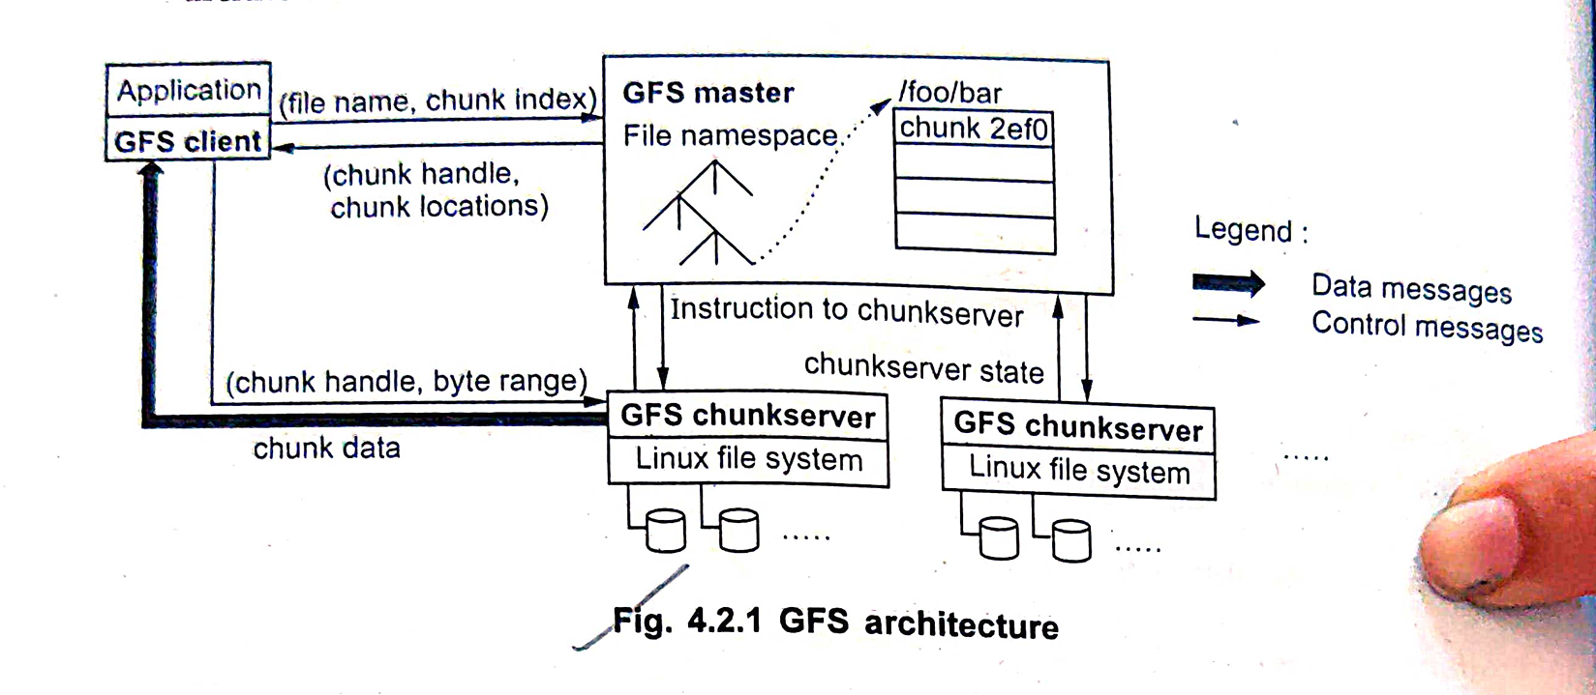  
Definition:** GFS is a "scalable distributed file system for large distributed data-intensive applications" created by Google.  
**Initial Use:** Initially used to store Google's search indexes and crawling data.  
**Current Use:** Now primarily used to store user-generated content.  
**Primary Purpose:** Built as the fundamental storage service for Google's search engine.  
**File Handling:** GFS typically handles a large number of huge files (100 MB or larger, with multiple GB files being common).  
**Block Size:** Google chose a large file data block size of 64 MB, significantly larger than the 4 KB in typical traditional file systems.  
**I/O Pattern:** The I/O pattern in Google applications is considered special.  
**Write Operations:** Files are typically written once, and write operations are often appending data blocks to the end of files.  
**Read Operations:** Expects a lot of large streaming reads and only a little random access.  
**Data Locality:** There is no data cache in GFS as large streaming reads and writes represent neither time nor space locality.

**Motivation behind GFS:**     
**Fault Tolerance and Auto-Recovery:** Needs to be built into the system due to the prevalence of issues like monitoring, error detection, fault tolerance, and automatic recovery. Failures are often caused by application bugs, OS bugs, human errors, and the failure of disks, memory, connectors, networking, and power supplies.     
**Standard I/O Assumptions:** Standard I/O assumptions (e.g., block size) need to be re-examined.  
**Record Appends:** Record appends are frequent for writing in Google applications, and GFS should be co-designed for this.

**GFS Architecture:** A GFS cluster consists of a **single master** and **multiple chunk servers**, and is accessed by multiple clients.     
**Basic Terms:**   
**Master:** Single server that coordinates system-wide activities. Can have read-only 'Shadow' servers.  
**Chunk:** 64 MB storage block representing a file or piece thereof.  
**Chunkserver:** Many servers that store chunks of data.  
**Replica:** Either primary or secondary chunks. A Chunkserver that replicates a given block.  
**Client:** Runs tasks on data. It is easy to run both a chunkserver and a client on the same machine, as long as machine resources permit.  
Files are divided into fixed-size chunks. Each chunk is identified by an immutable and globally unique 64-bit chunk handle assigned by the master at the time of chunk creation.     
Chunkservers store chunks on local disks as Linux files and read or write chunk data specified by a chunk handle and byte range. For reliability, each chunk is replicated on multiple chunkservers.     
The master maintains all file system metadata. This includes the namespace, access control information, the mapping from files to chunks, and the current locations of chunks.  
Clients interact with the master for metadata operations, but all data-bearing communication goes directly to the chunkservers.  
Neither the client nor the chunkserver caches file data. Figure 4.2.1 shows the GFS architecture.  
Clients never read and write file data through the master. Instead, a client asks the master which chunkservers it should contact. It caches this information for a limited time and interacts with the chunkservers directly for many subsequent operations.     
**First read/write process:**   
1. Using the fixed chunk size, the client translates the file name and byte offset specified by the application into a chunk index within the file.     
2. Then, it sends the master a request containing the file name and chunk index.  
3. The master replies with the corresponding chunk handle and the locations of the replicas. The client caches this information using the file name and chunk index as the key. The client then sends a request to one of the replicas, most likely the closest one.     
4. The request specifies the chunk handle and a byte range within that chunk.  
5. Further reads of the same chunk require no more client-master interaction until the cached information expires or the file is reopened.  
6. In fact, the client typically asks the master for multiple chunk handles in the same request, and the master can also include information for chunks immediately following those requested. This extra information sidesteps several future client-master interactions at practically no extra cost.     
----------------------------------------------------------------------------------------------------**---------------------------------------------------------------------------  
Q7)**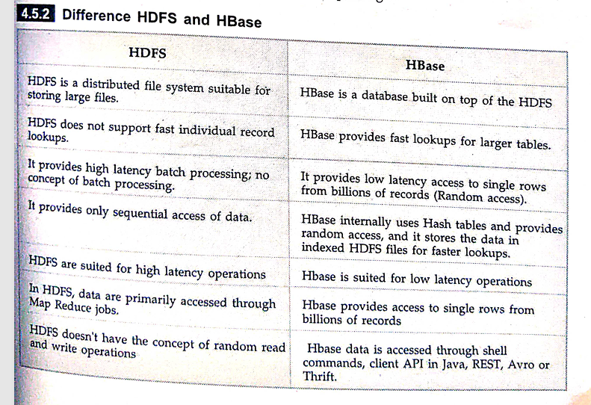----------------------------------------------------------------------------------------------------**---------------------------------------------------------------------------  
Q8)   
**----------------------------------------------------------------------------------------------------**---------------------------------------------------------------------------  
Q9)** **concepts of Business Continuity (BC) and Disaster Recovery (DR  
Business Continuity (BC):**Business continuity is more proactive and generally refers to the processes and procedures an organization must implement to ensure that mission-critical functions can continue during and after a disaster.BC involves more comprehensive planning geared toward long-term challenges to an organization's success. **Disaster Recovery (DR):**   Disaster recovery is more reactive and comprises specific steps an organization must take to resume operations following an incident.Disaster recovery actions take place after the incident, and response times can range from seconds to days.   Disaster recovery is a piece of business continuity planning and concentrates on processing data easily following a disaster.As cyberthreats increase and the tolerance for downtime decreases, business continuity and disaster recovery gain importance. These practices enable an organization to get back on its feet after problems occur, reduce the risk of data loss and reputational harm, and improve operations while decreasing the chaos of emergencies.

**Disaster Recovery Plan:**  
A disaster recovery plan is a plan designed to recover all the vital business processes during a disaster with in a limited amount of time. This plan has all the procedures required to handle the emergency situations.     
A disaster recovery process should have provable recovery capability, and hence it provides the most efficient method to be adopted immediately after a disaster occurs.  
Mostly the DRP has technology oriented methodologies and concentrates on getting the systems up as soon as possible, within a reasonable amount of time - Recovery Time Objective (RTO) and Recovery Point Objective (RPO) are the targets of DRP.     
The most successful disaster recovery strategy is the one that will never be implemented; therefore, risk avoidance is a critical element in the disaster recovery process.

**Business Continuity Plan:**  
Business continuity refers to the activities required to keep the organization running during a period of displacement or interruption of normal operations.     
BCP helps in continuing the business even after a disaster occurs.  
Business has to stay active during the crisis; if it closes its operations even for a day or a week, they are many chances that the organization will experience losses and will have to shut down.  
Moreover, legal issues can arise if the critical services are not provided to clients. This can lead to bad reputation and many more legal problems for an organization in addition to having the pain of being in the state of disaster. Hence an efficient BCP plan can be used to actively run and maintain the business activities.

**Threats in Disaster Recovery:  
1. Natural Disasters:**Earthquakes, floods, hurricanes, fires, and storms can physically damage data centers or IT hardware.These events can completely halt business operations if no off-site or cloud-based recovery exists. **2. Cybersecurity Threats:**Ransomware, malware, and hacking attacks can encrypt or destroy critical data.Cyberattacks may compromise sensitive business or customer data, leading to reputational and financial loss. **3. Hardware Failures:**Sudden failures of servers, storage devices, or networking components can cause system outages.Without redundancy or backups, such failures can result in permanent data loss. **4. Human Error:**Mistakes such as accidental deletion of data, misconfiguration of systems, or improper execution of scripts can lead to disruptions.Human error remains one of the most frequent and unpredictable threats. **5. Power Outages:**Unplanned power loss without proper backup (e.g., UPS or generators) can damage hardware and lead to unsaved data being lost.Prolonged outages can bring all services offline if backup solutions are inadequate.  
----------------------------------------------------------------------------------------------------**---------------------------------------------------------------------------  
Q10) Big Table, HBase, and Dynamo as NoSQL cloud data stores in cloud computing:  
Big Table (Google Cloud Bigtable):**Origin: Big Table is a highly scalable, distributed storage system developed by Google. It was the foundation for many of Google's core services. Google Cloud Bigtable is its fully managed NoSQL database service offered on Google Cloud Platform (GCP).Data Model: Big Table is a sparse, distributed, persistent multi-dimensional sorted map. The map is indexed by a row key, column family, and column qualifier; each value in the map is an uninterpreted array of bytes, along with a timestamp.Key Characteristics: Massive Scalability: Designed to handle petabytes of data and millions of reads/writes per second. It can dynamically scale up or down to accommodate changing workloads.High Performance: Optimized for low-latency reads and writes, making it suitable for real-time applications and analytics.Fully Managed: Google handles the infrastructure, scaling, and maintenance, allowing users to focus on application development.Integrated: Seamlessly integrates with other GCP services like Dataflow, Dataproc, and BigQuery.Consistency: Offers tunable consistency levels, allowing users to choose between strong consistency and higher availability/lower latency.Use Cases: Ideal for applications requiring high throughput and low latency for large datasets, such as IoT data, personalized recommendations, financial data analysis, and time-series data.

**HBase (Apache HBase):**Origin: HBase is an open-source, distributed, versioned, non-relational database built on top of Hadoop Distributed File System (HDFS). It is modeled after Google's Big Table.Data Model: HBase is a column-oriented NoSQL database. Data is stored in tables with rows and column families. Rows have a row key, and columns are grouped into column families. Within a column family, columns can be added dynamically, and each cell (intersection of row and column) can have multiple versions based on timestamps.  
Key Characteristics: Scalability: Can scale horizontally by adding more nodes to the Hadoop cluster.Fault Tolerance: Inherits fault tolerance from HDFS, ensuring data durability and availability.Column-Oriented: Offers efficient storage and retrieval for sparse data and analytical workloads that often access specific columns.Strong Consistency: Typically provides strong consistency for reads and writes.Open Source: Benefits from a large and active community.Use Cases: Well-suited for applications requiring random, real-time read/write access to large datasets, such as storing and querying sensor data, user activity tracking, and real-time analytics. It is often used in conjunction with Hadoop for batch processing.

**DynamoDB (Amazon DynamoDB):**Origin: DynamoDB is a fully managed NoSQL database service offered by Amazon Web Services (AWS). It provides fast and predictable performance with seamless scalability. 1     
Data Model: DynamoDB supports key-value and document data models. Data is stored in tables, and each item in a table has a primary key (either a partition key or a composite partition and sort key). Items can have attributes, and these attributes can vary from item to item (schema-less).  
Key Characteristics:   
Fully Managed: AWS handles all the underlying infrastructure, scaling, and maintenance.  
Automatic Scaling: Can automatically scale capacity up or down based on application needs.  
High Performance and Low Latency: Engineered for consistent, single-digit millisecond latency at any scale.  
Durability and Availability: Provides built-in high availability and data durability with synchronous replication across multiple Availability Zones.  
Flexible Data Model: Supports both key-value and document-based storage.  
Global Tables: Offers the option to create globally distributed databases that provide low-latency read and write access across multiple AWS regions.  
Use Cases: Suitable for a wide range of applications, including web and mobile backends, gaming, IoT, advertising technology, and serverless applications requiring high throughput and low latency.  
----------------------------------------------------------------------------------------------------**---------------------------------------------------------------------------  
Q11) General Security Advantages of Cloud-Based Solutions**• **Economies of Scale and Specialized Expertise:** Cloud providers often have significantly larger budgets and dedicated security teams with specialized expertise that most individual organizations cannot afford. This allows them to implement and maintain advanced security measures, tools, and personnel that might be beyond the reach of smaller companies. They can afford to hire top security talent, implement cutting-edge security technologies, and dedicate resources to proactive threat intelligence and response.

• **Centralized Security Management and Enforcement:** Cloud platforms provide a centralized infrastructure for managing and enforcing security policies across a vast environment. This can lead to more consistent and effective security controls compared to the often fragmented and inconsistent security landscapes of on-premises systems. Policies can be defined and applied uniformly across services and resources.

• **Automated Security Updates and Patching:** Cloud providers typically handle the underlying infrastructure's security updates and patching. This reduces the burden on the customer's IT staff and ensures that the infrastructure is protected against known vulnerabilities in a timely manner. While customers are still responsible for securing their applications and data within the cloud, the provider's automated patching of the base infrastructure is a significant advantage.

• **Advanced Security Technologies and Tools:** Cloud platforms offer access to a wide range of advanced security technologies and tools that might be expensive or complex to implement and manage in-house. These can include sophisticated intrusion detection and prevention systems, DDoS mitigation services, advanced identity and access management tools, data loss prevention (DLP) solutions, and comprehensive logging and monitoring capabilities.

• **Built-in Disaster Recovery and Business Continuity:** Cloud architectures are often inherently more resilient and offer built-in disaster recovery and business continuity capabilities. Data replication across multiple availability zones and regions, automated failover mechanisms, and robust backup and recovery services can provide a higher level of resilience than many individual organizations can achieve on their own. This helps ensure data availability and business continuity in the event of a disaster.

• **Compliance and Governance Frameworks:** Major cloud providers often adhere to a wide range of industry-specific and regulatory compliance standards (e.g., HIPAA, PCI DSS, GDPR). This can simplify the compliance efforts for customers operating in regulated industries, as the underlying infrastructure already meets many of these requirements. Providers often provide documentation and tools to assist customers with their own compliance obligations.  
----------------------------------------------------------------------------------------------------**---------------------------------------------------------------------------  
Q12)** **What are different types of disasters and how the disaster recovery is done on cloud platform.   
Different Types of Disasters:** Disasters that can disrupt IT infrastructure and business operations are varied. They can be broadly categorized as follows: **1. Natural Disasters:** These are events caused by natural forces and are often unpredictable and widespread. Examples include: * **Earthquakes:** Can cause physical damage to infrastructure, power outages, and network disruptions.   
**Hurricanes, Cyclones, Typhoons:** High winds, flooding, and storm surges can damage facilities and disrupt connectivity.   
**Floods:** Can inundate data centers and damage equipment.   
**Wildfires:** Can physically destroy facilities and disrupt power and network access.   
**Extreme Temperatures:** Prolonged heatwaves or cold spells can strain cooling systems and cause hardware failures.   
**Landslides and Mudslides:** Can damage infrastructure and disrupt access.

**2. Human-Caused Disasters:** These are events resulting from human actions, either intentional or unintentional. Examples include:  
 **Power Outages:** Can be widespread or localized due to grid failures, accidents, or intentional attacks.   
**Hardware Failures:** Server malfunctions, storage failures, network equipment breakdowns.   
**Software Failures:** Operating system crashes, application errors, database corruption.   
**Network Outages:** Connectivity issues due to equipment failure, cable cuts, or cyberattacks.   
**Data Corruption:** Errors during data storage, transfer, or processing.   
**Cyberattacks:** Ransomware, malware infections, denial-of-service attacks, data breaches.   
**Insider Threats:** Intentional or accidental damage or data loss caused by employees or contractors.   
 **Terrorism and Sabotage:** Intentional attacks on physical infrastructure or data.   
**Human Error:** Mistakes in configuration, maintenance, or operation leading to outages or data loss.

**Disaster Recovery on Cloud Platforms:** Cloud platforms offer a range of services and features that significantly enhance disaster recovery capabilities compared to traditional on-premises infrastructure. Here's how disaster recovery is typically done on cloud platforms:

**1. Replication and Backup Services:** * **Data Replication:** Cloud providers offer services to replicate data synchronously or asynchronously across multiple availability zones (within a region) or even across different geographic regions. This ensures that if one location fails, data is readily available in another. * **Backup Services:** Automated and scalable backup solutions allow organizations to create point-in-time copies of their data and applications, storing them securely and redundantly.

**2. Infrastructure as Code (IaC):** * Cloud infrastructure can be defined and provisioned using code (e.g., AWS CloudFormation, Azure Resource Manager, Google Cloud Deployment Manager). This allows for the rapid and automated creation of recovery environments in different locations.

**3. Automated Failover and Recovery:** * Cloud platforms provide mechanisms for automated failover of applications and services to secondary locations in case of a primary site failure. This minimizes downtime and ensures business continuity. * Orchestration tools can automate the entire recovery process, including starting up secondary instances, restoring data, and reconfiguring network settings.

**4. Scalability and Elasticity:** * Cloud environments can quickly scale up resources in the recovery site to handle the workload from the failed primary site. Elasticity ensures that organizations only pay for the resources they need during a disaster recovery event.

**5. Variety of DR Strategies:** * Cloud platforms support various DR strategies, allowing organizations to choose the one that best fits their RTO (Recovery Time Objective) and RPO (Recovery Point Objective) requirements and budget: * **Backup and Restore:** Periodically backing up data and restoring it in a secondary location. Suitable for less critical workloads with longer RTOs. * **Pilot Light:** Maintaining a minimal, always-on environment in the cloud with critical configurations and data replicated. Full-scale environment is spun up during a disaster. * **Warm Standby:** Maintaining a scaled-down, always-on environment in the cloud that can be quickly scaled up to full production capacity during a disaster. * **Hot Standby (Active-Active):** Running a fully redundant environment in the cloud, with traffic actively load-balanced between the primary and secondary sites. Provides the lowest RTO and RPO.

**6. Geographic Diversity:** * Cloud providers have data centers located in multiple geographic regions around the world. This allows organizations to replicate their infrastructure and data to geographically distant locations, mitigating the risk of regional disasters affecting both primary and recovery sites.

**7. Cost-Effectiveness:** * Compared to building and maintaining a dedicated physical DR site, cloud-based DR can be more cost-effective. Organizations can leverage pay-as-you-go models and avoid significant upfront capital expenditure.

**8. Testing and Drills:** * Cloud platforms facilitate regular DR testing and drills without impacting the production environment. Isolated recovery environments can be easily spun up and tested to validate the effectiveness of the DR plan.  
----------------------------------------------------------------------------------------------------**---------------------------------------------------------------------------  
Q13)**  **Explain the features and advantages of Dynamo DB. Explain how it is different than RDBMS.  
Features and Advantages of Amazon DynamoDB:** Amazon DynamoDB is a fully managed NoSQL key-value and document database that delivers single-digit millisecond performance at any scale. Its key features and advantages include:

**Features:**  
**Key-Value and Document Data Model:** Supports flexible schema-less data, allowing each item to have its own set of attributes. You can store structured data as JSON, XML, or other document formats.  
**Automatic Scaling:** Dynamically scales read and write capacity based on the application's needs without manual intervention or downtime.  
**Fully Managed:** AWS handles all the operational aspects, including server provisioning, patching, backups, replication, software installation, and maintenance.  
**Built-in Security:** Integrates with AWS Identity and Access Management (IAM) for fine-grained access control and offers encryption at rest and in transit.  
**Transactions:** Supports ACID (Atomicity, Consistency, Isolation, Durability) transactions across one or more items within a single DynamoDB table.  
**On-Demand Capacity Mode:** Offers a pay-per-request pricing option where you only pay for the read and write requests your application performs, making it cost-effective for unpredictable workloads.

**Advantages:**  
**Scalability:** Can handle virtually unlimited amounts of data and traffic, making it suitable for highly demanding applications.  
**Performance:** Provides consistent, low-latency read and write operations, crucial for real-time applications.  
**Ease of Use:** Fully managed nature reduces operational overhead and allows developers to focus on application logic rather than database administration.  
**Flexibility:** Schema-less design accommodates evolving data structures and diverse data types.  
**Reliability:** Built-in high availability and durability ensure that applications remain available and data is protected.  
**Cost-Effective:** Offers various pricing models to optimize costs based on workload patterns.  
**Differences Between DynamoDB and RDBMS (Relational Database Management Systems)**